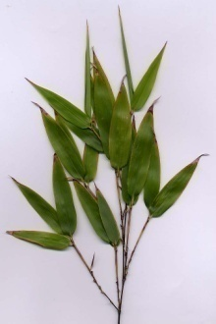Beautiful Bamboo

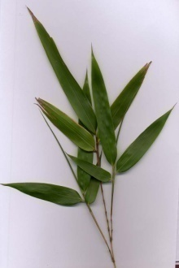Bamboo has a long history of use in the world, particularly in developing nations. It's historically been used for everything from food and fodder to musical instruments and construction material. For centuries, millions of people have depended on this plant, which is known as 'friend of the people' in China, and 'wood of the poor' in India. But the demand for bamboo has been increasing in other parts of the world as well, especially as it relates to furniture, accent pieces, and flooring. More and more, people are seeing the value and beauty of using bamboo in their homes to achieve modern day fashion with an ethnic flavor. Entire books have been written on the subject, including *Bamboo Style* and *Bamboo World*.

There are many different sizes and varieties of bamboo. It is both tropical and subtropical, growing in climates as diverse as jungles and mountainsides. Actually giant, woody grasses, it is very adaptable, with some species deciduous and others evergreen. Although there isn't yet a complete knowledge about this plant, there are believed to be between 1100 and 1500 different species of bamboo.

Because they are so easy to grow in such a variety of climates, there is a plant available for just about anyone who wishes to grow one in their backyard. Some dwarf species include **chimonobambusa marmorea**, **indocalamus 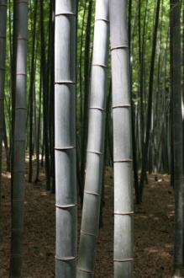tessellatus**, and **pleioblastus chino vaginatus**. Also suitable for the personal garden are those categorized as mid size. Examples of these types of plants are **bambusa glaucophylla** and **otatea acuminata aztecorum**. Classified as grasses, the color range is from light green leaves and culms (stems) to dark, rich shades of green or some combination thereof. Plant starts and seeds are easier to find than ever, being available at nurseries and through mail order.

Bamboo is quickly becoming an important economic factor in many developing nations. A sixty foot tree cut for marketing can take up to 60 years to replace, whereas a sixty foot bamboo can take as little as 60 days to reach marketability. And the majority of bamboo destined for the world market is harvested by women and children, most of whom live at or below subsistence levels in poor nations. So as production increases, so does support for the economies of those countries that produce it.

Choosing bamboo as part of home or garden design makes sense on many levels. Not only does it have an appealing look, but it supports the environment as well as the countries that produce it.